**Name:** B. Nageswar

**Reg-No**: 192372005

11.Illustrate the concept of multithreading using a C program.

**Aim:**

To demonstrate the concept of multithreading in C by creating multiple threads that execute concurrently.

**Algorithm:**

1. **Start**.
2. Initialize the program and include the necessary libraries.
3. Define the functions that will be executed by the threads.
4. Create threads using the pthread_create function.
5. Execute the threads concurrently.
6. Use pthread_join to wait for threads to finish execution.
7. Print the results from each thread to demonstrate multithreading.
8. **End**.

**Procedure:**

1. Import pthread.h and stdio.h libraries.
2. Define the function for thread execution logic.
3. Use pthread_create to create multiple threads and pass the function as an argument.
4. Use pthread_join to ensure main program waits for all threads to finish.
5. Compile and run the program to observe concurrent thread execution.

### Code:

### #include <stdio.h>

### #include <pthread.h>

### #include <unistd.h>

### void *print_message(void *thread_id) {

### int tid = *(int *)thread_id;

### printf("Thread %d is running\n", tid);

### sleep(1); // Simulate work

### printf("Thread %d has finished\n", tid);

### return NULL;

### }

### int main() {

### pthread_t threads[3];

### int thread_ids[3];

### for (int i = 0; i < 3; i++) {

### thread_ids[i] = i + 1;

### pthread_create(&threads[i], NULL, print_message, &thread_ids[i]);

### }

### for (int i = 0; i < 3; i++) {

### pthread_join(threads[i], NULL);

### }

### printf("All threads have completed execution.\n");

### return 0;

### }

### ****Result****:

When executed, the program creates three threads. Each thread prints its start and end message, demonstrating concurrent execution

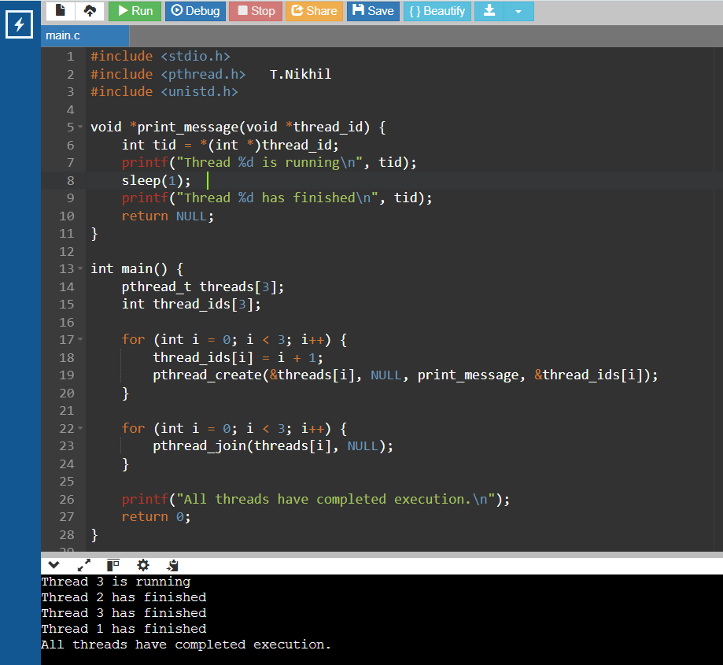**Output:**